Why Teach Financial Literacy?
Lifetime Skills and Critical Thinking
Financial Stability/Security
Understand Debt, Investing, and Saving

Learn the Value and Basic Handling of Money
Learn to Use Financial Tools

Learn Responsibility and Independence

New Opportunities – We are here to help!
Check out our website: https://www.newopp.org/ or Call Us at 712-792-9266

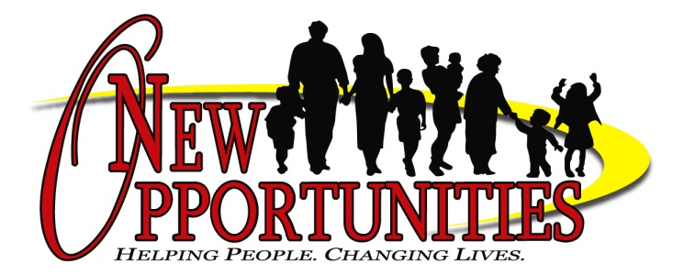

3-5 YEARS SHOULD KNOW THE FOLLOWING AS BEGINNING FINANCIAL LITERACY LESSONS:
- You need money to buy things
- You earn money by working
- You may have to wait before you can buy something you want
- There is a difference between things you want and need

6-10 YEAR OLDS ARE CAPABLE OF HAVING A CONVERSATION ABOUT THE FOLLOWING FINANCIAL LITERACY TOPICS:
- You need to make a choice about how to spend your money
- It’s good to shop around and compare prices before you buy
- It can be dangerous to share information online
- Putting your money in a savings account will protect it and pay you interest

11-13 YEARS CAN BETTER UNDERSTAND MORE COMPLEX ISSUES REGARDING FINANCES. SOME TOPICS TO DISCUSS INCLUDE:
- You should save at least a dime for every dollar you receive
- Entering a credit card number online is risky because someone could steal your information
- The earlier you start to save, the faster you’ll benefit from compound interest, which means your money earns interest on your interest
- A credit card is a type of loan: if you don’t pay your bill in full every month, you’ll be charged interest and owe more than you originally spent

14-18 YEARS HAVE DISPOSABLE INCOME AND ARE THINKING AHEAD TO COLLEGE YEARS. HERE’S WHAT THEY SHOULD KNOW:
- It’s important to know what a college will cost before you choose it
- You should avoid using credit cards to buy things you can’t afford to pay for with cash
- Your first paycheck may seem smaller than expected since money is taken out for taxes
- A great place to save and invest money you earn is in a Roth IRA

18+ YEARS AND OLDER WHO ARE LIVING INDEPENDENTLY AT COLLEGE NEED TO KNOW TO PLAN FOR THEIR FUTURE. HERE ARE SOME TOPICS TO DISCUSS WITH THEM:
- You should use a credit card only if you can pay off the money owed in full
- You need health insurance
- Putting your eggs in one basket can be a risky way to invest; consider a diverse mix of stocks, bonds, and cash
- Always consider two factors before investing: the risks and the annual expenses

Leticia, Hughes, S., Berkowitz, E., Brianne, Andrea, & Rana. (2016, May 25). The Best Free Resources for Teaching Kids Financial Literacy. Retrieved from https://techsavvymama.com/2016/04/best-free-resources-for-teaching-kids-financial literacy.html?utm_source=feedburner&utm_medium=feed&utm_campaign=Feed: TechSavvyMama (Tech Savvy Mama)
Why Teach Financial Literacy?
Lifetime Skills and Critical thinking  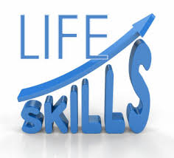 | Learn the Value and Basic Handling of Money | Learn Responsibility and Independence  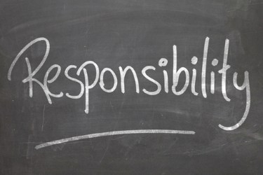
Financial Stability/Security  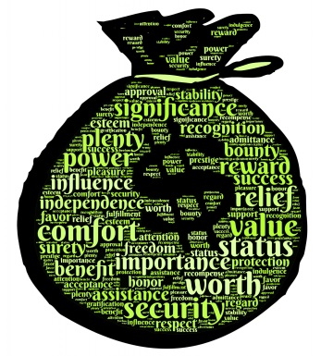 | Learn to Use Financial Tools  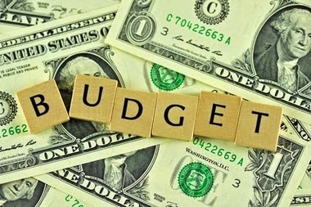 | Understand Debt, Investing, and Saving  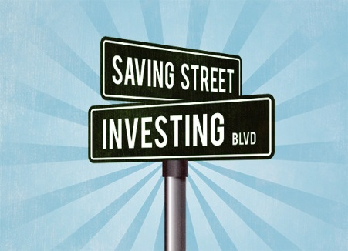

Prepared for the Future!

New Opportunities – We are here to help!
Check out our website: https://www.newopp.org/ or Call Us at 712-792-9266

3-5 YEARS SHOULD KNOW THE FOLLOWING AS BEGINNING FINANCIAL LITERACY LESSONS:
- You need money to buy things
- You earn money by working
- You may have to wait before you can buy something you want
- There is a difference between things you want and need

6-10 YEAR OLDS ARE CAPABLE OF HAVING A CONVERSATION ABOUT THE FOLLOWING FINANCIAL LITERACY TOPICS:
- You need to make a choice about how to spend your money
- It’s good to shop around and compare prices before you buy
- It can be dangerous to share information online
- Putting your money in a savings account will protect it and pay you interest

11-13 YEARS CAN BETTER UNDERSTAND MORE COMPLEX ISSUES REGARDING FINANCES. SOME TOPICS TO DISCUSS INCLUDE:
- You should save at least a dime for every dollar you receive
- Entering a credit card number online is risky because someone could steal your information
- The earlier you start to save, the faster you’ll benefit from compound interest, which means your money earns interest on your interest
- A credit card is a type of loan: if you don’t pay your bill in full every month, you’ll be charged interest and owe more than you originally spent

14-18 YEARS HAVE DISPOSABLE INCOME AND ARE THINKING AHEAD TO COLLEGE YEARS. HERE’S WHAT THEY SHOULD KNOW:
- It’s important to know what a college will cost before you choose it
- You should avoid using credit cards to buy things you can’t afford to pay for with cash
- Your first paycheck may seem smaller than expected since money is taken out for taxes
- A great place to save and invest money you earn is in a Roth IRA

18+ YEARS AND OLDER WHO ARE LIVING INDEPENDENTLY AT COLLEGE NEED TO KNOW TO PLAN FOR THEIR FUTURE. HERE ARE SOME TOPICS TO DISCUSS WITH THEM:
- You should use a credit card only if you can pay off the money owed in full
- You need health insurance
- Putting your eggs in one basket can be a risky way to invest; consider a diverse mix of stocks, bonds, and cash
- Always consider two factors before investing: the risks and the annual expenses

Leticia, Hughes, S., Berkowitz, E., Brianne, Andrea, & Rana. (2016, May 25). The Best Free Resources for Teaching Kids Financial Literacy. Retrieved from https://techsavvymama.com/2016/04/best-free-resources-for-teaching-kids-financial literacy.html?utm_source=feedburner&utm_medium=feed&utm_campaign=Feed: TechSavvyMama (Tech Savvy Mama)

